WEEK 4.2

Aim
To compute the transpose of a given matrix by converting rows into columns.

Algorithm
- Find the number of rows m and columns n in the matrix.
- Create a new matrix transpose of size n × m.
- Traverse the original matrix:
  - Assign transpose[j][i] = matrix[i][j].
- Return the transposed matrix.
Program:
class Solution {
public int[][] transpose(int[][] matrix) {
int m = matrix.length;
int n = matrix[0].length;
int[][] result = new int[n][m];
for (int i = 0; i < m; i++) {
for (int j = 0; j < n; j++) {
result[j][i] = matrix[i][j];
}
}
return result;
}
}

Output:
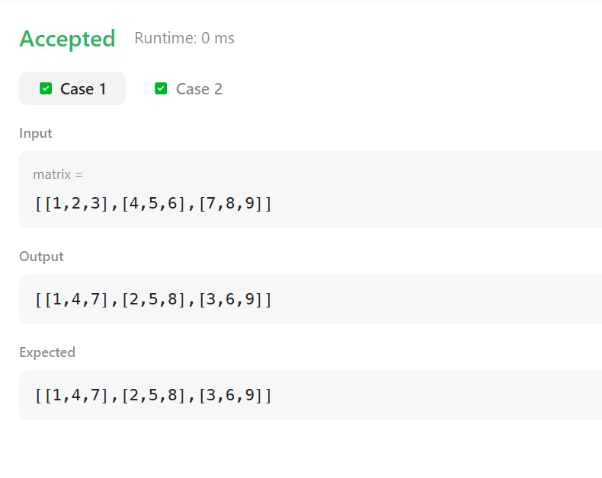

Result:
Thus the implementation of the matrix transpose was executed successfully and output was verified.
Aim:
To move all zeroes in the given array to the end while maintaining the relative order of non-zero elements.

ALGORITHM:
- Initialize an index k = 0.
- Traverse the array:
  - If the element is non-zero, place it at index k and increment k.
- After traversal, fill the remaining positions with 0.
- Print the modified array.
Program:
class Solution {
public void moveZeroes(int[] nums) {
int k = 0;
for (int i = 0; i < nums.length; i++) {
if (nums[i] != 0) {
nums[k++] = nums[i];
}
}
while (k < nums.length) {
nums[k++] = 0;
}
}
}

Output:


Result:
Thus the implementation of the move zeroes in the leet code was executed successfully and output has been verified successfully.

AIM:
To convert time from 12-hour AM/PM format to 24-hour military format.

ALGORITHM:
- Extract hours, minutes, seconds, and AM/PM.
- If time is AM:
  - Convert 12 AM to 00.
- If time is PM:
  - Add 12 to hours if not 12 PM.
- Return the converted time.

Program:
class Result {
public static String timeConversion(String s) {
String period = s.substring(8);
int hour = Integer.parseInt(s.substring(0, 2));
String rest = s.substring(2, 8);

if (period.equals("AM")) {
if (hour == 12) hour = 0;
} else {
if (hour != 12) hour += 12;
}

return String.format("%02d", hour) + rest;
}
}

Output:
07:05:45PM
19:05:45

Result:
Thus the implementation of the time conversion in hacker rank was executed successfully and output was verified.

AIM:
To calculate the absolute difference between the sums of the matrix’s primary and secondary diagonals.

ALGORITHM:
- Initialize primarySum = 0 and secondarySum = 0.
- Traverse the matrix:
  - Add matrix[i][i] to primary diagonal sum.
  - Add matrix[i][n - i - 1] to secondary diagonal sum.
- Return absolute difference.

Program:
class Result {
public static int diagonalDifference(List<List<Integer>> arr) {
int n = arr.size();
int primary = 0, secondary = 0;

for (int i = 0; i < n; i++) {
primary += arr.get(i).get(i);
secondary += arr.get(i).get(n - i - 1);
}

return Math.abs(primary - secondary);
}
}

Output:
3
11 2 4
4 5 6
10 8 -12

Result:
Thus the implementation of the diagonal difference in hacker rank was executed successfully and output has been verified.

